**Workshop 05**

**Workshop 5 - Computer Architecture**

The questions in this workshop are derived primarily from the content of [chapter 5 of the textbook.](http://www.nand2tetris.org/chapters/chapter%2005.pdf)Read this chapter as a guide to these questions.

**Question 1 - Memory Mapped I/O**

The Hack Machine has memory-mapped I/O. Briefly describe what Memory Mapped I/O is. What alternatives are there to mapped I/O? Why is memory mapped I/O better than this alternative?

**Question 2 - Writing to the Screen**

Write a program that writes 15 black pixels to the first word of screen memory.

Now write a program that writes 16 black pixels to the first word of screen memory (this is going to involve slightly different code).

**Question 3 - Reading from the Keyboard**

Write code that puts the scan code of the most recently pressed key into a variable called *scan.*Note that - the value of the key pressed may only appear in the keyboard register while the key is being held down so you will have to find a way for this last value read to be retained.

**Question 4 - C-Instruction to Input Wires to ALU**

Look at the tables on slide 14 of the [notes from lecture nine](https://forums.cs.adelaide.edu.au/forums/pluginfile.php/58003/mod_page/content/4/Lecture9a.pdf) from this course. This contains the tables describing the function of the bits of the C-instruction. Look at the diagram of the ALU below:

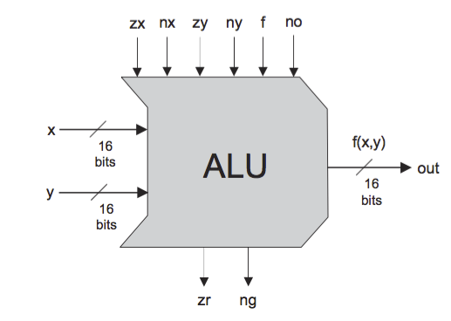

briefly describe which bits (wires) of the c-instruction map to the input wires: zx, nx, zy, ny, f and no?  You may also find table 2.6 from the textbook useful in answering this question.

**End of Questions**